1. Selection Sort

Question 1: Trophy Ranking System
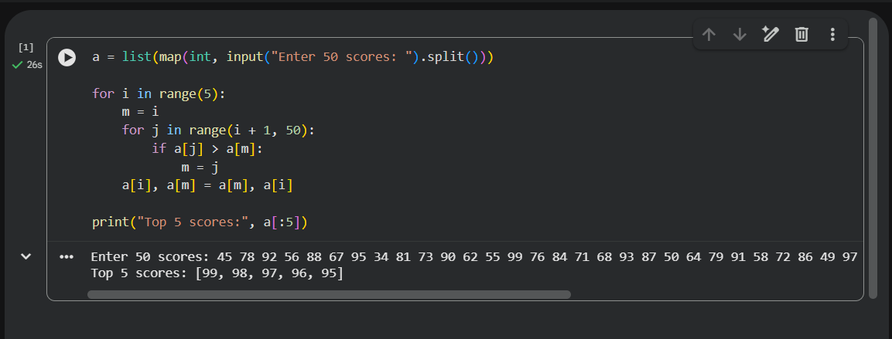

Question 2: Memory-Constrained Embedded Device
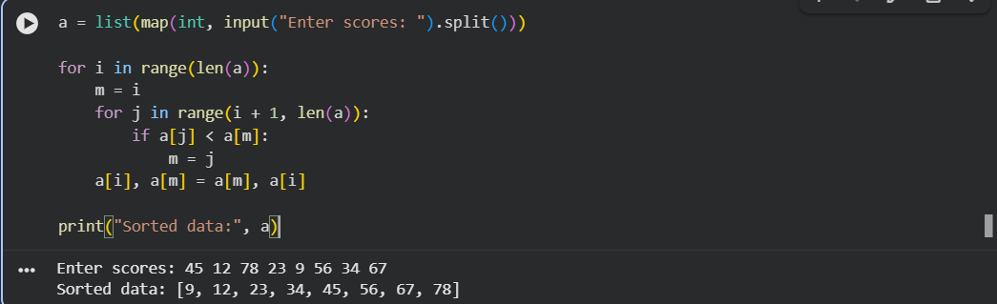

Question 3: Library Book Reordering
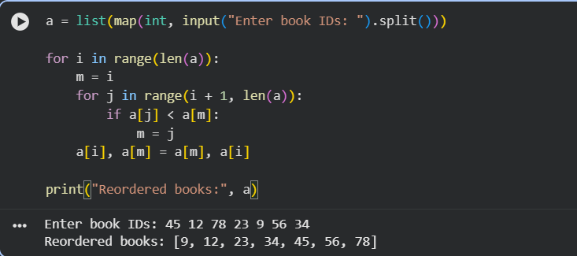

Question 4: Contest Prize Distribution
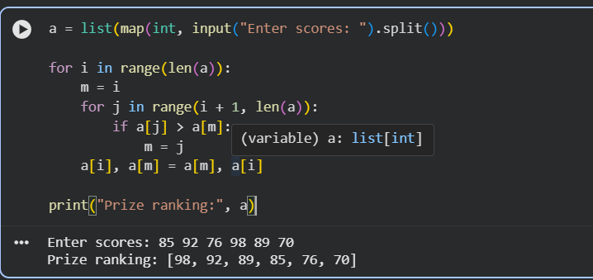
Question 5: Small Dataset in a Mobile App

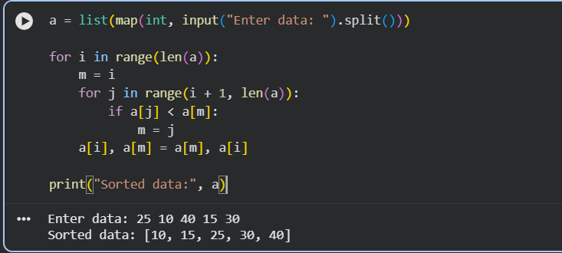

2. Bubble Sort

Question 1: Exam Result Slip Correction

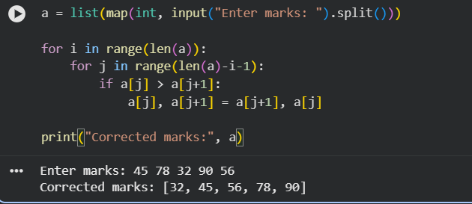

Question 2: Traffic Signal Priority Queue
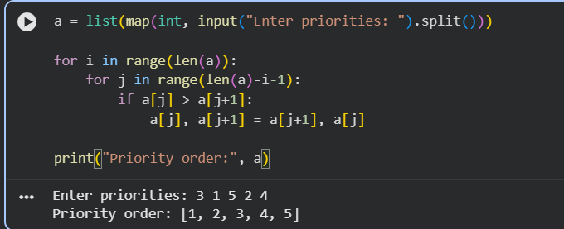
Question 3: Bubble Sort Visualization Tool
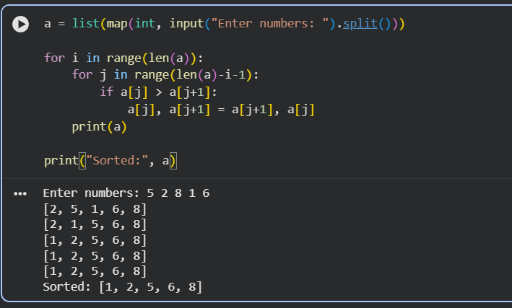

Question 4: Sorting Sensor Alerts by Severity
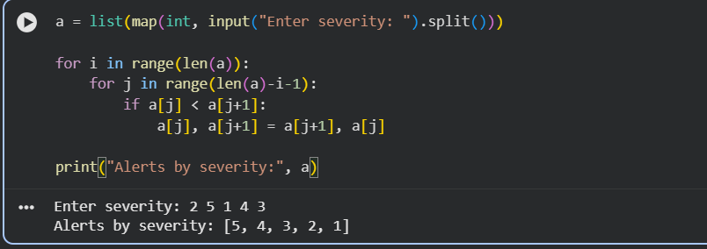

Question 5: Card Game Hand Sorting
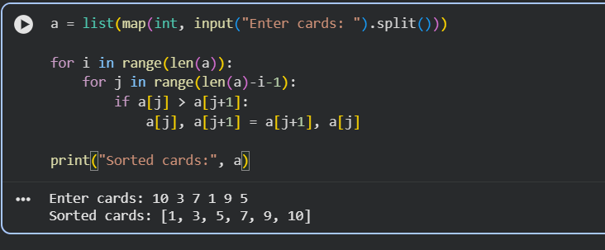

3. Insertion Sort

Question 1: Live Leaderboard Updates
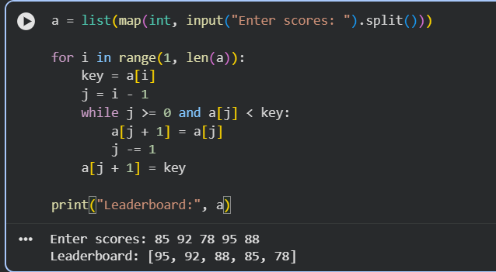

Question 2: Card Sorting While Playing
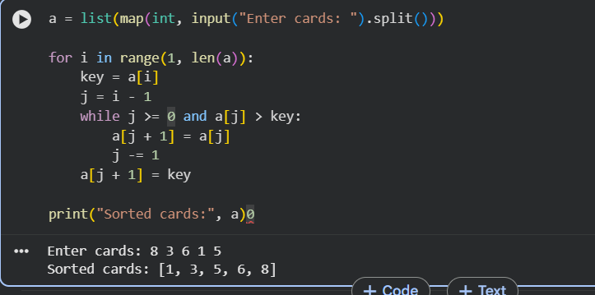
Question 3: Real-Time Stock Price Feed
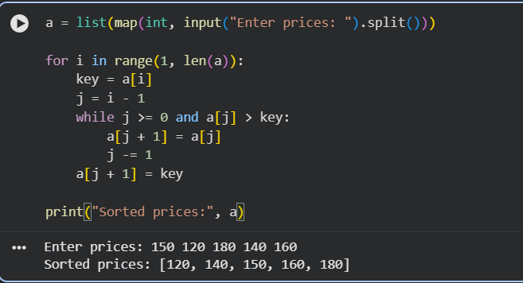

Question 4: Playlist Reordering by Recently Added
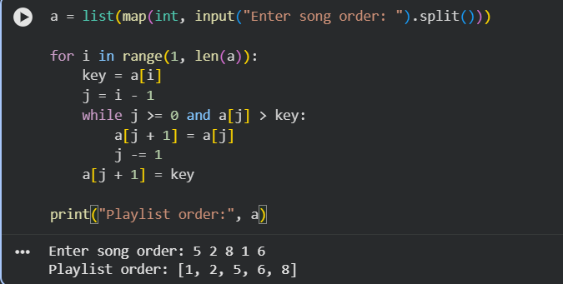

Question 5: Nearly Sorted Sensor Log Correction
